June 13, 2018

**Tax Supervising & Conservation Commission**

Board Chair Juli Valeske

Burlington Water District

PO Box 270

St. Helens , Oregon 97051

Board Chair Valeske:

The Tax Supervising and Conservation Commission has completed its review and consideration of Burlington Water District’s 2018-19 Approved Budget.

We received the District’s 2018-19 budget on May 21, 2018. Our staff found the document to be in substantial compliance with Local Budget Law (ORS 294.605-705). The budget estimates and levy rate were as follows:



Tax Levy: Permanent Rate $3.4269 per $1,000 of assessed value

At its meeting today, the Tax Supervising and Conservation Commission certified by a majority vote that it has no objections to adoption of the budget or recommendations on the process.

The Commission would like to acknowledge the substantial improvement to the District’s budget process that has occurred over the last two years. The Commissioners know this is not an easy transformation, and appreciate your efforts in making it happen.

Thank you for the opportunity to serve your district.

Yours truly,

TAX SUPERVISING & CONSERVATION COMMISSION

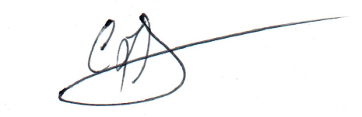

Craig Gibons

Executive Director

c: Summer Sears